URL | Screenshot for 360 Vacation center
http://designdisease.com/45-inspiring-travel-and-tourism-website-designs/comment-page-4/#comment-98600
http://blog.alaskatravel.com/alaska-wildlife-guaranteed-viewing/comment-page-1/#comment-389892
https://travelblog.expedia.co.in/india/goa-tourism-guide/#comment-389
http://wild-spirit.net/us-tourist-visa-interview-experience/#comment-71884 | 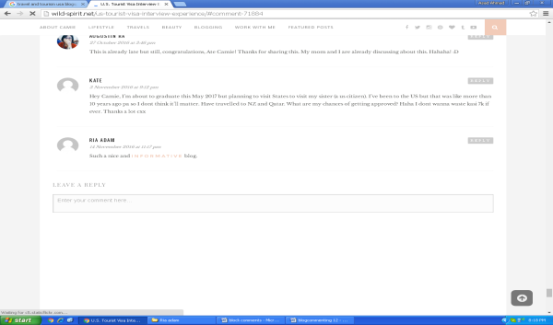
https://hasbrouck.org/cgi-bin/mt/mt-continue.cgi
http://nomadisbeautiful.com/travel-blogs/laos-good-and-bad-forgotten-country/#comment-44480
http://blog.straytravel.com/2016/11/07/stray-hop-on-hop-off-returns-to-hahei/#comment-115302
http://www.traveltoodle.com/destinations/asia/malaysia/destinations-in-malaysia.html#comment-179 | 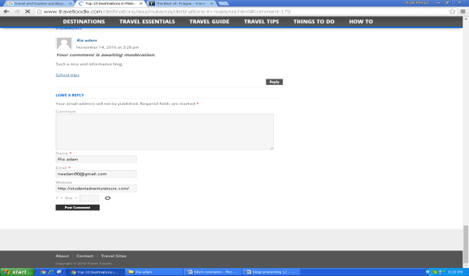
http://www.journeymexico.com/blog/sun-sand-culture-magical-villages-next-beach-vacation#comment-11394 | 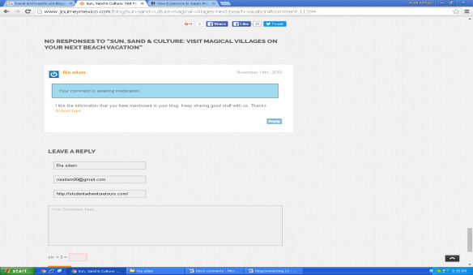
http://nerdnomads.com/expensive-japan-travel-cheap#comment-2811 | 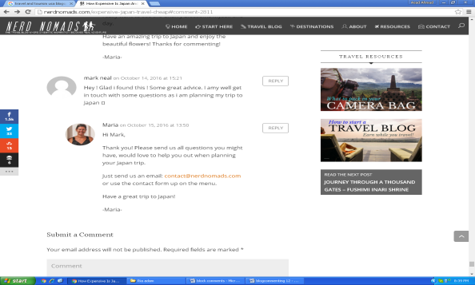
http://www.thisworldrocks.com/travel-guides/top-lists/good-travel-blog-name-ideas/#comment-341032 | 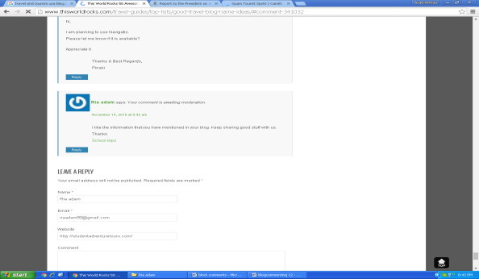
http://itscamilleco.com/2015/01/travel-diary-sightseeing-around-guam/#comment-289967 | 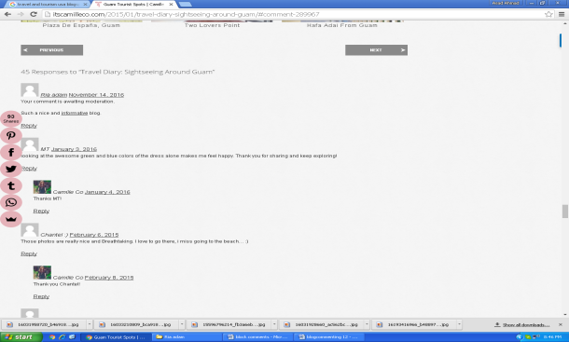
http://travelbloggerbuzz.com/amex-platinum-vs-chase-sapphire-reserve-travel-hacking-demise-trumped/#comment-394998 | 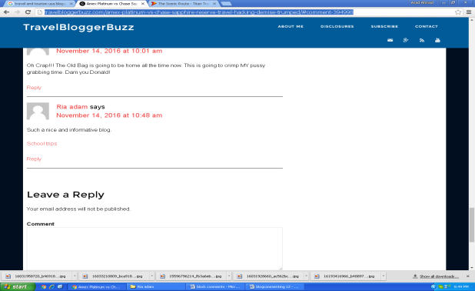
http://www.barcelonacitytours.com/blog/uncategorized/museu-egipci-de-barcelona/#comment-4020 | 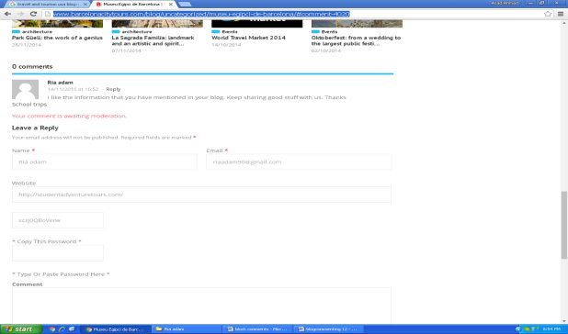
https://american-traveler.blogspot.com/2016/11/yesterday-it-was-jews-tomorrow-itll-be.html?showComment=1479139159900#c7699790459526010709

